07-Apr-22

# **Experiment 11 - Intermediate code generation- Quadruple, Triple, Indirect Triple**

Dhawal Patil

RA1911003010575

CSE A2

Aim:

A program to implement Intermediate code generation – Quadruple, Triple, Indirect Triple.

Algorithm:

The algorithm takes a sequence of three-address statements as input. For each three address

statements of the form a:= b op c perform the various actions. These are as follows:

1. Invoke a function getreg to find out the location L where the result of computation b op c should be stored.
2. Consult the address description for y to determine y'. If the value of y currently in memory and register both then prefer the register y' . If the value of y is not already in L then generate the instruction MOV y' , L to place a copy of y in L.
3. Generate the instruction OP z' , L where z' is used to show the current location of z. if z is in both then prefer a register to a memory location. Update the address descriptor of x to indicate that x is in location L. If x is in L then update its descriptor and remove x from all other descriptors.
4. If the current value of y or z have no next uses or not live on exit from the block or in register then alter the register descriptor to indicate that after execution of x : = y op z those register will no longer contain y or z.

Code:

#include<stdio.h>

#include<ctype.h>

#include<stdlib.h>

#include<string.h>

void small();

void dove(int i);

int p[5]={0,1,2,3,4},c=1,i,k,l,m,pi;

char sw[5]={'=','-','+','/','*'},j[20],a[5],b[5],ch[2];

void main()

{

printf("Enter the expression:");

scanf("%s",j);

printf("\tThe Intermediate code is:\n");

small();

}

void dove(int i)

{

a[0]=b[0]='\0';

if(!isdigit(j[i+2])&&!isdigit(j[i-2]))

{

a[0]=j[i-1];

b[0]=j[i+1];

}

if(isdigit(j[i+2])){

a[0]=j[i-1];

b[0]='t';

b[1]=j[i+2];

}

if(isdigit(j[i-2]))

{

b[0]=j[i+1];

a[0]='t';

a[1]=j[i-2];

b[1]='\0';

}

if(isdigit(j[i+2]) &&isdigit(j[i-2]))

{

a[0]='t';

b[0]='t';

a[1]=j[i-2];

b[1]=j[i+2];

sprintf(ch,"%d",c);

j[i+2]=j[i-2]=ch[0];

}

if(j[i]=='*')

printf("\tt%d=%s*%s\n",c,a,b);

if(j[i]=='/')

printf("\tt%d=%s/%s\n",c,a,b);

if(j[i]=='+')

printf("\tt%d=%s+%s\n",c,a,b);if(j[i]=='-')

printf("\tt%d=%s-%s\n",c,a,b);

if(j[i]=='=')

printf("\t%c=t%d",j[i-1],--c);

sprintf(ch,"%d",c);

j[i]=ch[0];

c++;

small();

}

void small()

{

pi=0;l=0;

for(i=0;i<strlen(j);i++)

{

for(m=0;m<5;m++)

if(j[i]==sw[m])

if(pi<=p[m])

{

pi=p[m];

l=1;

k=i;

}

}

if(l==1)

dove(k);

else

exit(0);

}

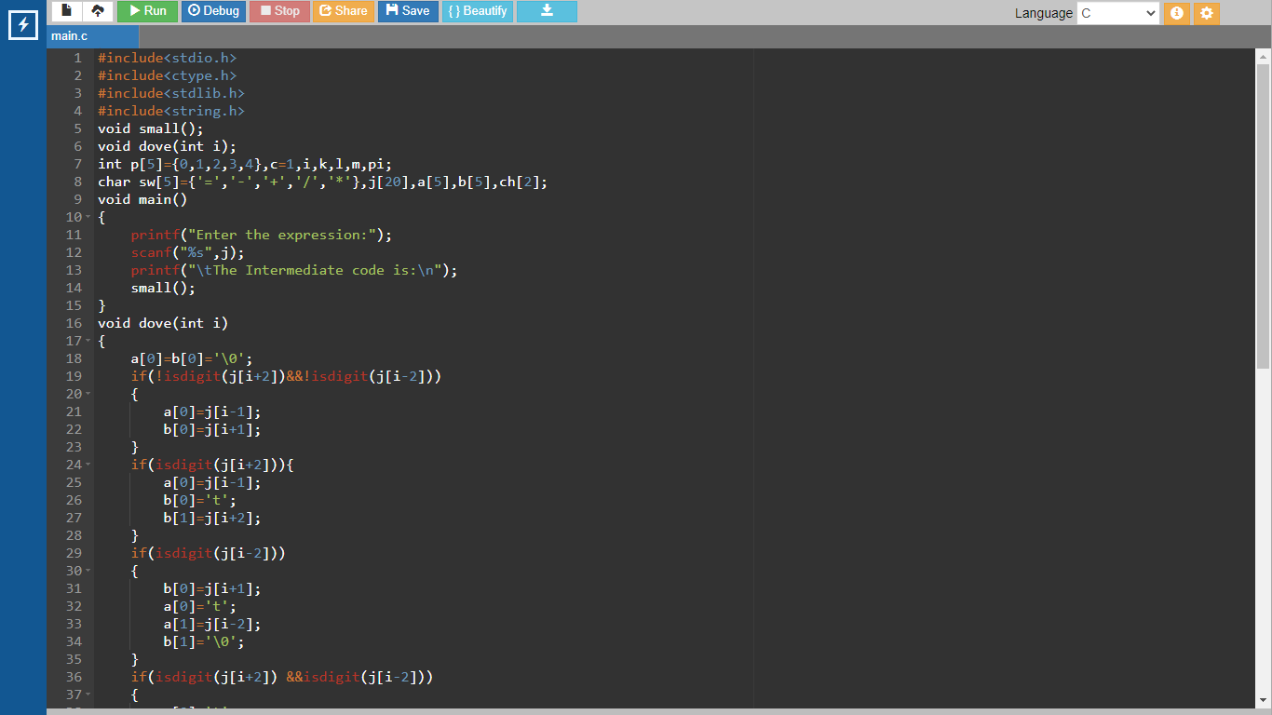

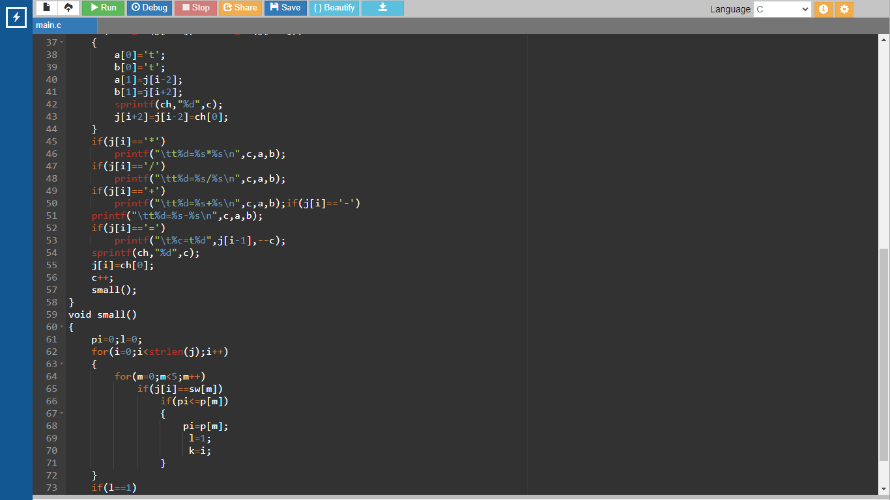

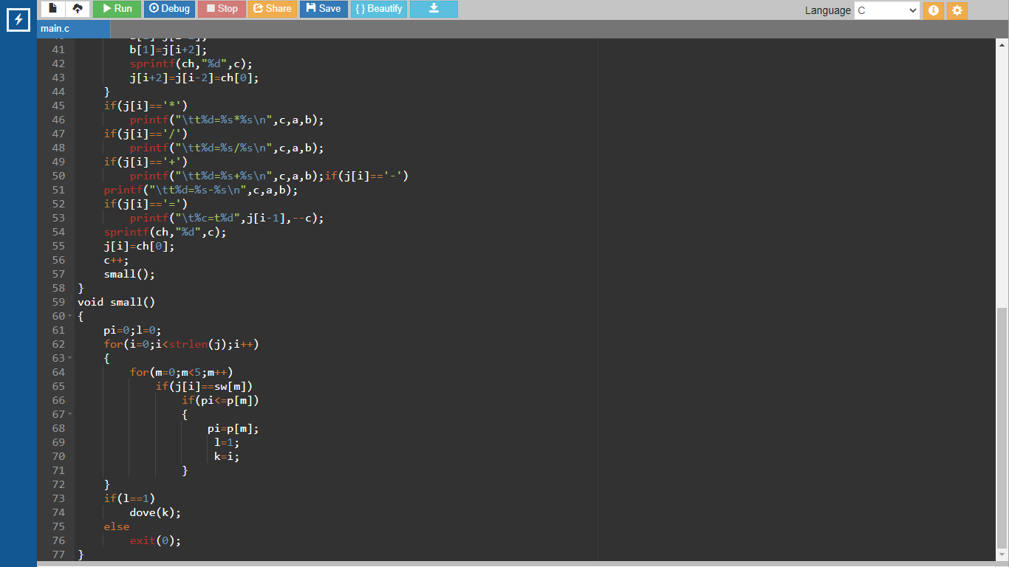

Output:

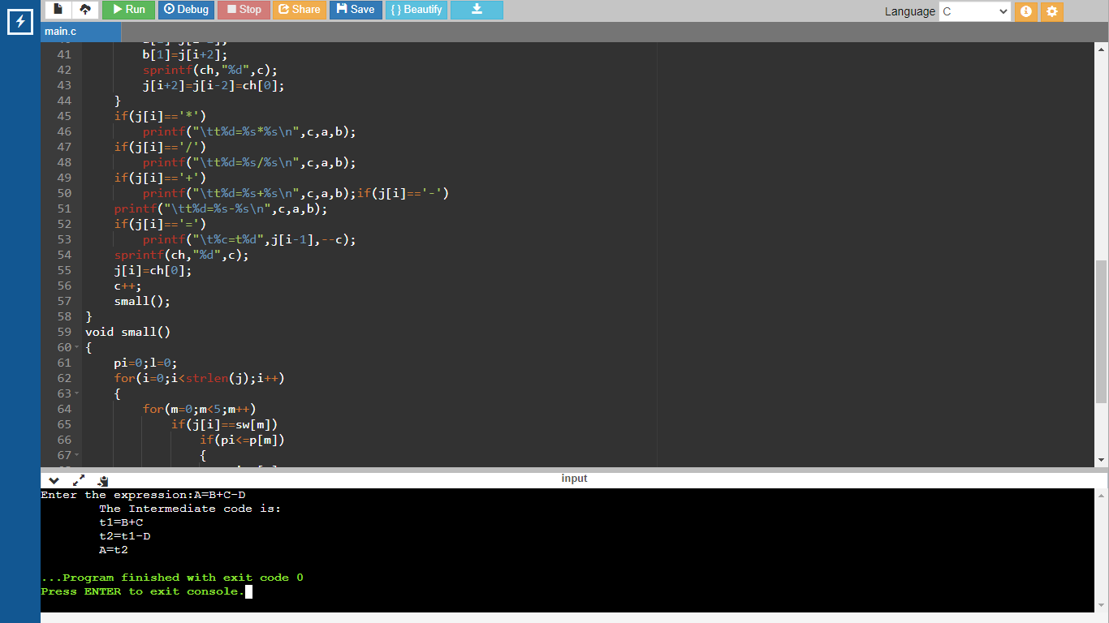

Result:

The program was successfully compiled and run.